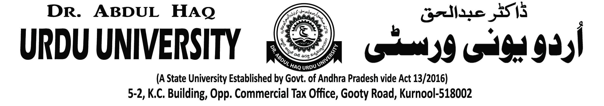

Dr. Abdul Haq Urdu University NSS UNIT

NSS unit organised an International Women’s Day programme in University Campus on 05-03-2020. In this programme Honourable Vice-Chancellor Prof K.Muzaffer Ali, Registrar Prof.N.R.Venkata Ramana Reddy, NSS Co-ordinator Dr.S Mahaboob Basha, Principal in-charge Mohammed Irfan, Faculty Members and Students also participated. Following are the images of the event.

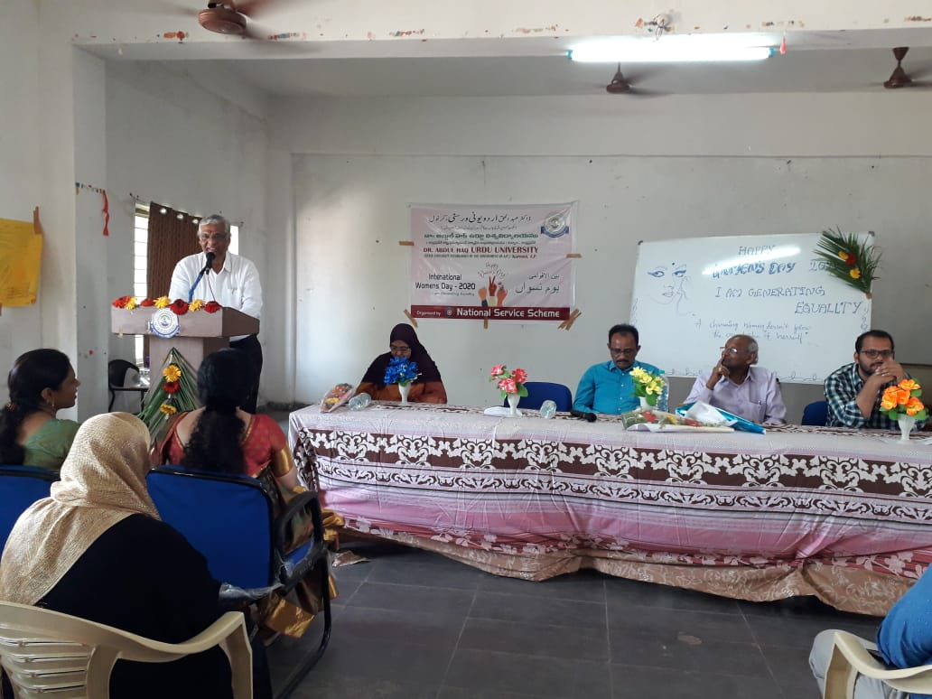 | 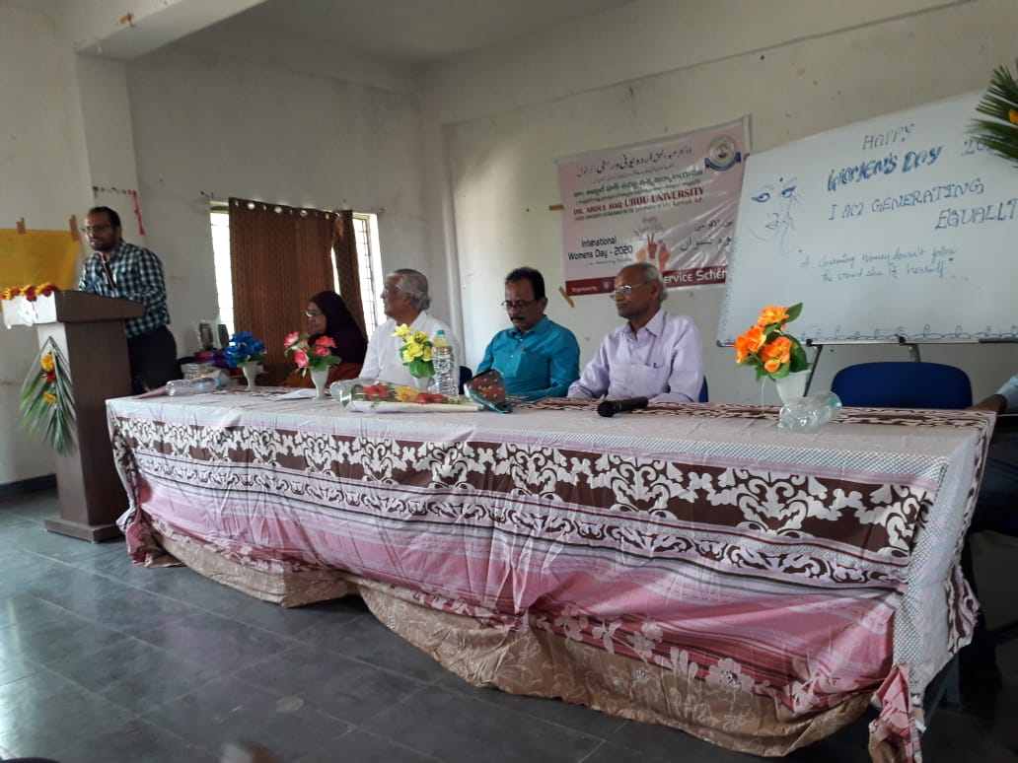
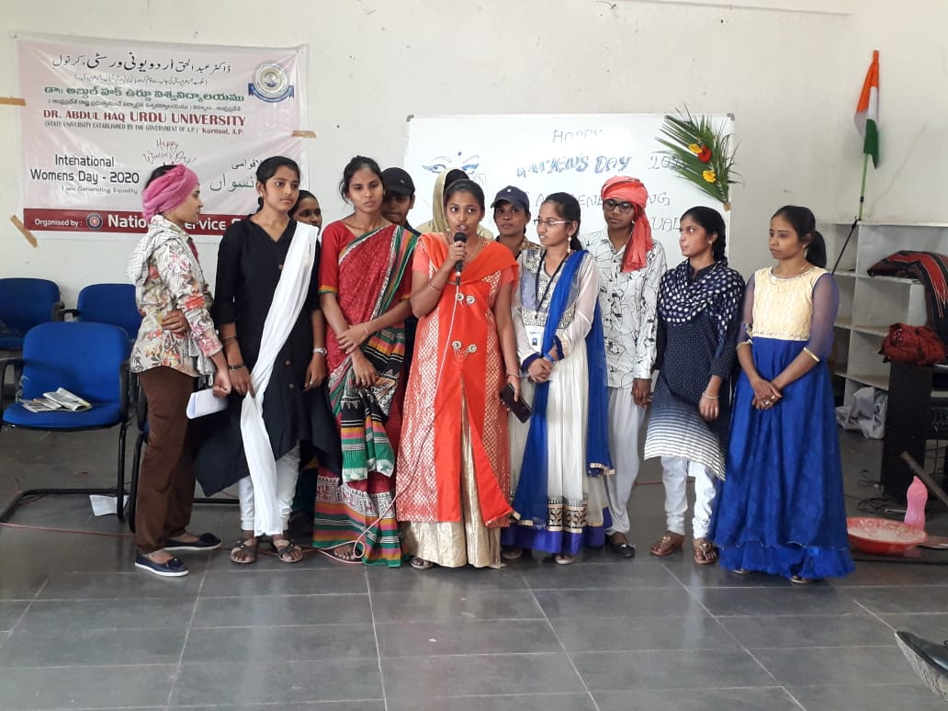 | 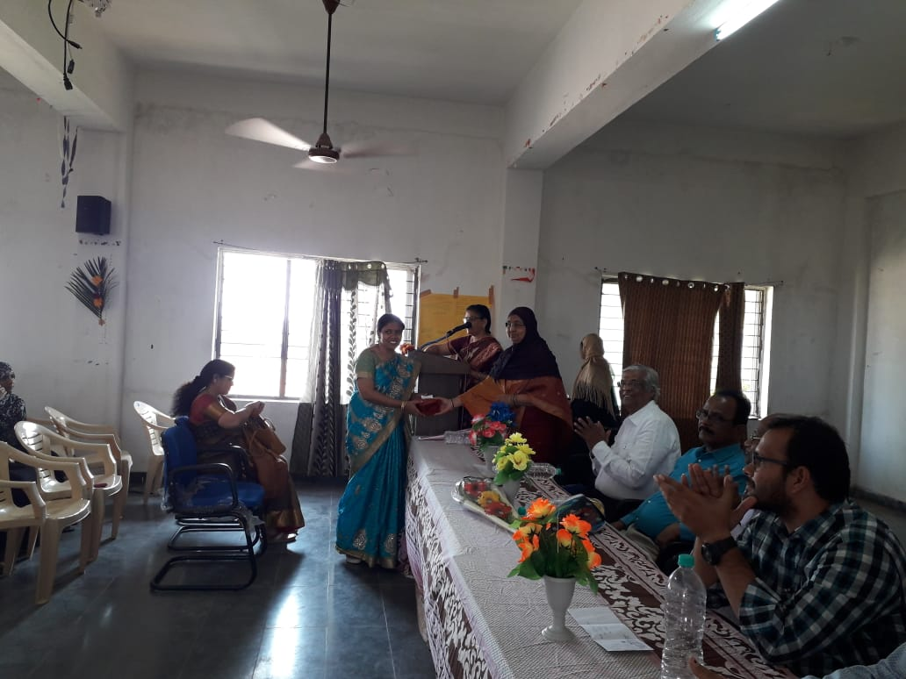
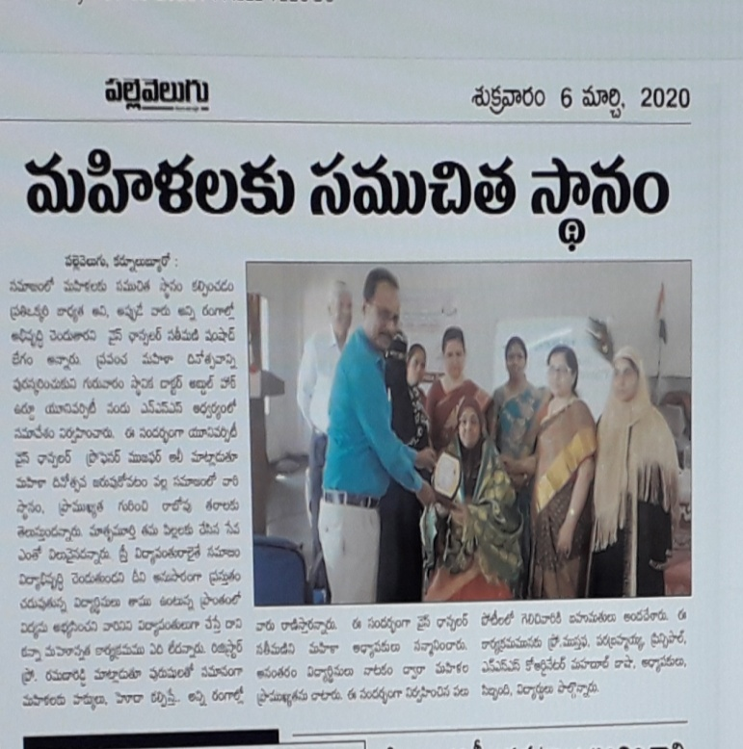 | 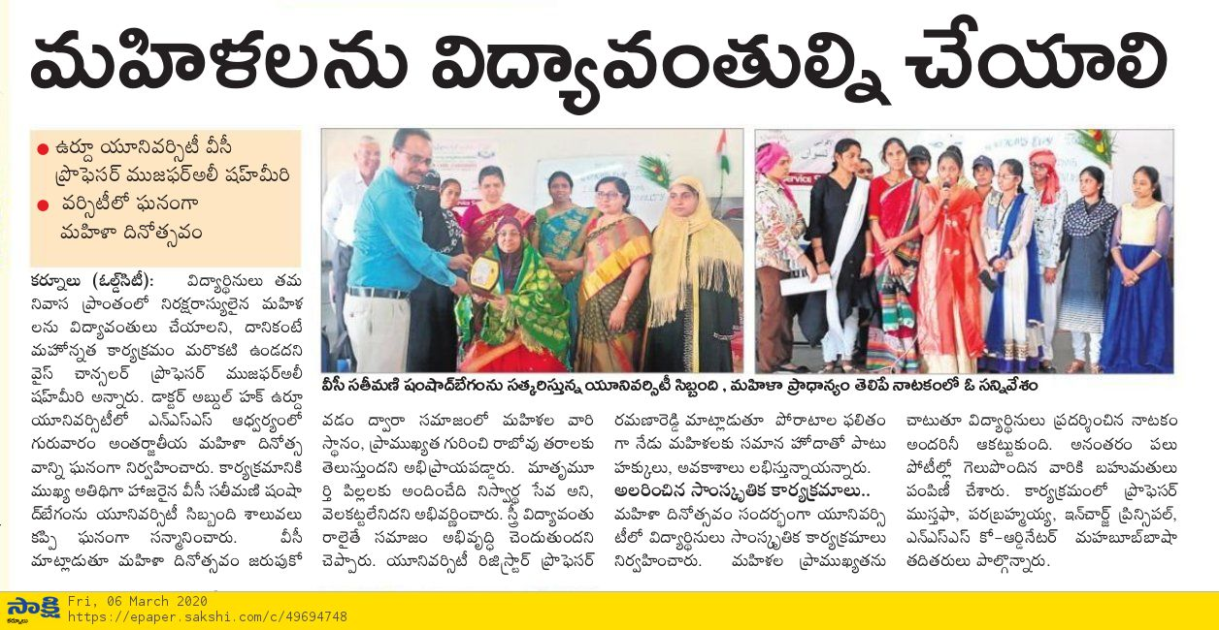
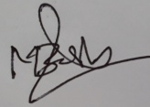

NSS Co-ordinator
(Dr. S.Mahaboob Basha)

